**2022 Fall CPSC 240-1 Final Test Concepts**

**December 7, 2022: 12:00m -2:00pm**

**Policies**

Place answers in this document in the space immediately below each question.

Add your name and email address on the last page.

Return this document with the answers before the stated end time: 2:00pm

The return document must be in one of these 3 formats: **doc**, **docx**, or **odt**. Documents in another format will be discarded.

You are responsible for your own equipment. Make sure your laptop has a full charge or is plugged into 120 volt electricity. Make sure your internet connection is secure and stable.

The point value of this test is 100 points. The more complex questions have a higher point value then the simple questions although the points of individual questions are not now shown on this test document.

“IEEE” is sometimes used in place of “IEEE754”.

The “blank” answer rule applies.

Multiple submissions are accepted. The test with the newest time stamp will be graded.

**Extended time**: You may extend your time by 1 hour, but then you have to commit to making this test have ‘A’ quality answers everywhere. Don’t submit this stuff “I’ll throw out some guessed answers and then see what sticks.” If you’re using the extra hour on this test then your answers have to be A-grade quality. That’s the contract: extra hour equals ‘A’.

Continue to next page.

1. The first assembly programmer in the world lived a long time making assembly programs. What is the name of this person and when did the person die?

Kathleen Booth

2. The computer science department maintains a server for use by students. The server has all the programs of the tool chain. Three questions:

What is the name of the server?

What is the log in command you would use at your computer to gain access to that server?

A CentOS-based shell server is available through secure shell (ssh) and secure file transfer protocol (sftp). The hostname is ecs.fullerton.edu. If your email address is malcolm@csu.fullerton.edu, then your username is malcolm. Command is requirted to connect to ecs.fullerton.edu will be

‘ssh bill[@ecs.fullerton.edu](mailto:malcolm@ecs.fullerton.edu)‘.

3. Show steps to do the following.

Create a 64-bit random number and place it in r12. Treat it as a float number.

Write statements that will check the number in r12. If that number is a nan then replace it with zero. If that number is not a nan then do not change it.

Finally, place a copy of r12 into xmm0.

generateNumber:

;Generate Random Number

mov rax, 0

rdrand r12

;Check if Random Number

mov rbx, r12

mov rcx, 0x7ff0000000000000

add rbx, rcx

shr rbx, 32

cmp rbx, 2047

je nonumFound

jmp storeNumber

;Function to set r12 to 0.

nonumFound:

mov r12, 0

jmp storeNumber

;Store final number in xmm0

storeNumber:

cvtsi2sd xmm0, r12

4. Add these two numbers: 17.125 x 2^14 and 7.875 x 2^-11

Show the final sum in IEEE754-32bit format.

As usual with all math problem show sufficient intermediate step to convince the grader (professor) that you really know how to do it.

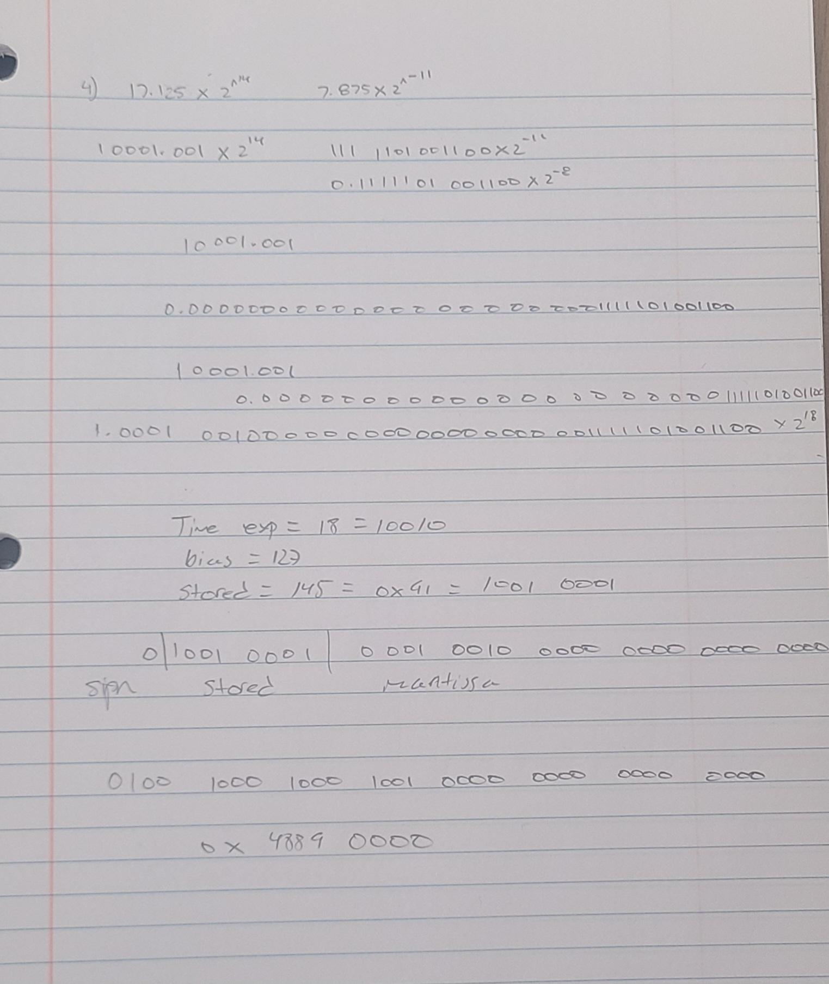

5. In ATT syntax what is the prefix character prepended to the names of registers?

$

6. In ordinary assembly we often use declarations like this.

capacity dq 31, 46, 40, 28

This is an array showing the maximum seating capacity of room 101, 104, 300, and 408 respectively.

With inline assembly there is no .data segment and no .bss segment.

Show how to get this array moved into a block of inline assembly.

Second part: what is the name of the array viewed from the assembly block. Make clear what is the array’s name.

Blank

7. We know that the purpose of a EULA is to withhold rights from the end user.

What are the rights conferred to the end-user by most open source licenses such as GPL and others?

Open source software licenses generally grant 4 freedoms (or rights) to the end

consumer.

* 1. The right to receive the source code with the product itself.
* 2. The freedom distribute the software to others via any medium
* 3. The right to modify the program.
* 4. The freedom to distribute the modified product via any media.

8. Suppose the file selection.asm contains a valid test copy of the selection sort function written in X86. This selection sort will sort an array of doubles. selection.asm carries and open source license, and you are free to use it.

You are writing a C++ function: void catalog(char [ ], long limit);

The function catalog wants to call the function selection.

What is the prototype that must be place in catalog in order for catalog to call selection?

Extern “C” void selection(double[]);

9. This semester we learned two syscalls: how to input a string and how to output a string.

The program you are constructing has outputted this prompt: “Please enter your name”.

Assume everyone’s name has 32 or less characters.

Show how to input the user name using a syscall.

Disregard issues of names of less than 32 chars or names longer than 32 chars. This question does not deal with those details. Simply show assembly instructions for inputting a string of 32 chars by using a syscall.

segment .data

prompt db “Please enter your full name”, 10, 0

sysread equal 0

stdin 0

length equal 32

segment .bss

userinputname resb 32

segment .text

manager:

mov rax, sysread

mov rdi, stdin

mov rsi, userinputname

mov rdx, length

syscall

10. Suppose the following is declared in the .data segment.

conclusion db “The sum of %ld and %ld is %ld”,10,0

Where is the string stored?

Heap

11. The following is a familiar instruction:

movsd xmm7, [rsp+8]

Clasify the two operands.

Movsd accepts two operands. The first operand is the destination operand while the second operand is the source operand. Both operands use an XMM register. [rsp+8] is the stack pointer with 8 bytes allocated to it.

12. An array of quadwords has been declared in the .bss segment. r8 holds the start of the array.

The lower half of rax holds a 32-bit float number. Show how to copy that float number into cell number 7’s second half (upper half).

; r8 = start of array

; rax = float number to copy

; Calculate the address of cell number 7 in the array

mov r9, 7

mul r9, 8

add r9, r8

; Copy the lower half of rax into the upper half of cell number 7

mov [r9+4], ax

13. A classroom contains a large number of student desks. They are arranged in rows of 7 desks per row. The instructor unlocks the door and everyone enters the room. The instructor says to fill front seats first and to fill successive back seats a needed. How many students will be in the back (partially filled) row of desks.

Show instruction how to solve this problem. Assume: r8 is holding integer 7 and r9 is holding the number of students.

mov rax, r9

cqo

idiv r8

mov r10, rdx

14. There is an integer in the low byte of rcx. Maybe the integer is -47 using 8-bit twos complement numbering system.

Show how to extend that one byte number to all of rcx.

blank

15. The array claim has been declared in a C++ function.

char claim[ ] = “Randal is a funny guy”;

Use gdb to change the letter ‘f’ to a ‘b’.

set var claim[12] = ‘b’

16. Use gdb to change the value in the upper fourth of xmm9 to be 3.5 in IEEE754 format.

set $xmm9.v4_float = 3.5

17. This array camera has been declared in the .data segment.

camera dd 254, 64, -2094, 3089, 16, -500

Use gdb to change the value in cell #3 from 3089 to 99.

set var camera[3] = ‘99’

18. What is the name of the set of all xmm registers.

SSE

19. Convert 10.3 to IEEE754-32bits.

As usual with math problems show enough of your work to convince the grader that you know more than how to use a calculator.

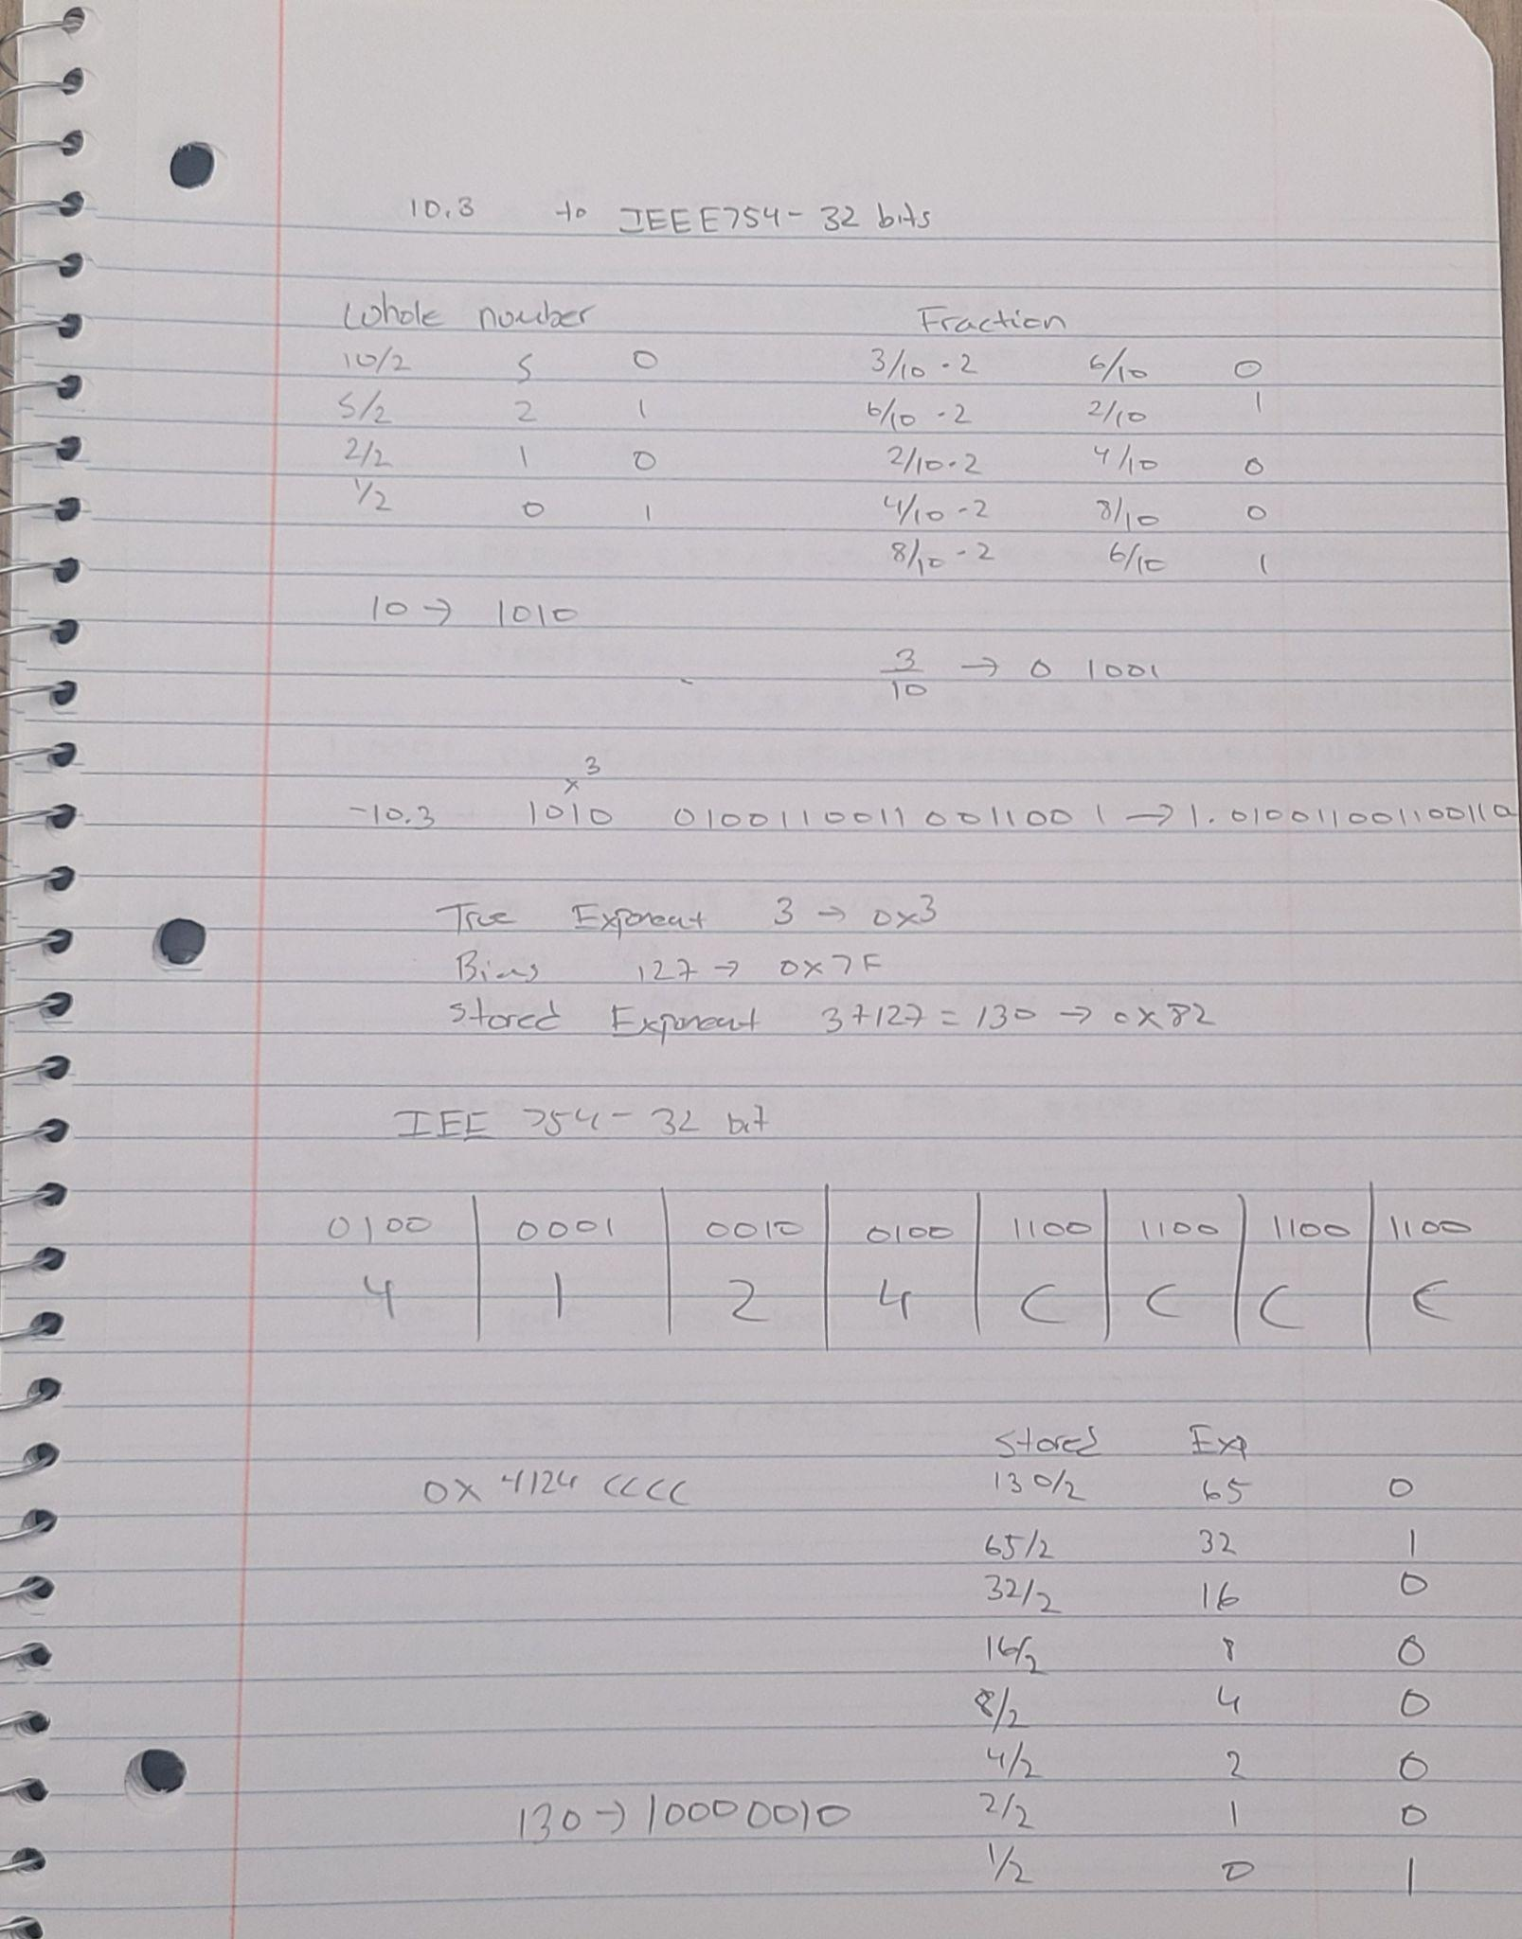

20. Which one(s) are not a valid reason for learning to program in assembly?

a.) Learn the individual parts of the tool chain.

b.) Learn how to get started in developing a software project

c.) Discover how functions are called

d.) Learn how to build better (faster) algorithms

e.) Learn how to use AI to avoid doing the hard part of the programming.

f.) Learn how to integrate source files of multiple languages into a single executable program.

Select the answers that are not true.

Learn how to use AI to avoid doing the hard part of the programming.

//You see the test really does have 20 or less questions.

//You have extra time on this test. Go back and make sure your answers are 100% perfect. You have a computer in front of you. You can test those gdb answers to make sure they are perfect. Some of you need 100% to avoid re-taking this course again. Now is the time to make sure this test is perfect.

Signature on the next page.

Your digital signature:

Juan Uriarte

Your preferred email address:

uriarte.juan@csu.fullerton.edu

(Email may be the csuf mail or may be other mail.)

Send this document in doc, docx, or odt format to holliday@fullerton.edu

Come back on Monday for the second half of the final exam.

My portal shows the final for 240-1 is Monday, Dec 12, 1pm-3pm

The issue of an extra free hour has not yet been decided. If and extra hour is to be included then it will be added at the end, ie, 1pm-4pm.

My hope is that most people finish during the first 2 hours. The extra hour is for checking everything.

==Add nice comments

==Test the program with unusual inputs

==Make sure the bash file is Linux compatible (LF for line endings).

==Bash files made with a Windows based editor do not execute in Linux.

==Think in advance: what kind of unusual inputs will the professor use attempting to break my program.